DEPARTMENT OF MECHANICAL ENGINEERING
National Institute of Technology Calicut

25th NOVEMBER, 2020

ME4098D Project

Enrolment Form

1. Broad Area of the Project:

Machine Design/ Robotics Stream /Industrial Engineering and Management Stream / Materials Science and Manufacturing Stream / Thermo-fluid Stream/ Interdisciplinary (please specify)

2. Proposed Methodology:

Analytical / Computational / Design and Analysis / Experimental / Fabrication and Testing

3. Details of the Members of the Project Group:

S. No. | Roll No. | Name of the Students | CGPA | Signature
1. | B180712ME | POOLA ROHITH | 8.71 | 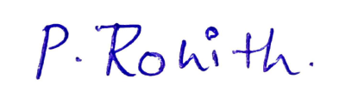
2. | B180161ME | AKONDI SAI MANOJ | 8.66 | 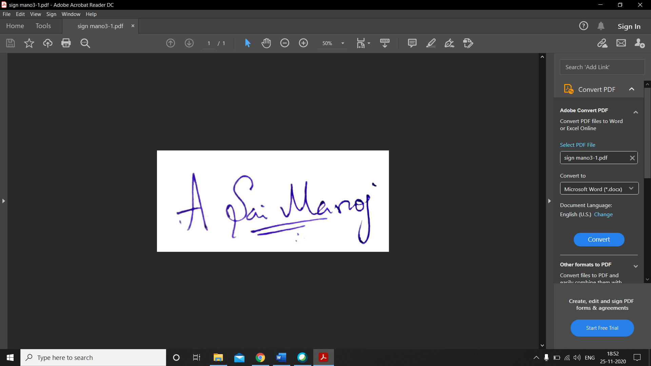
3. | B180129ME | MAMIDI TEJONATH | 6.14 | 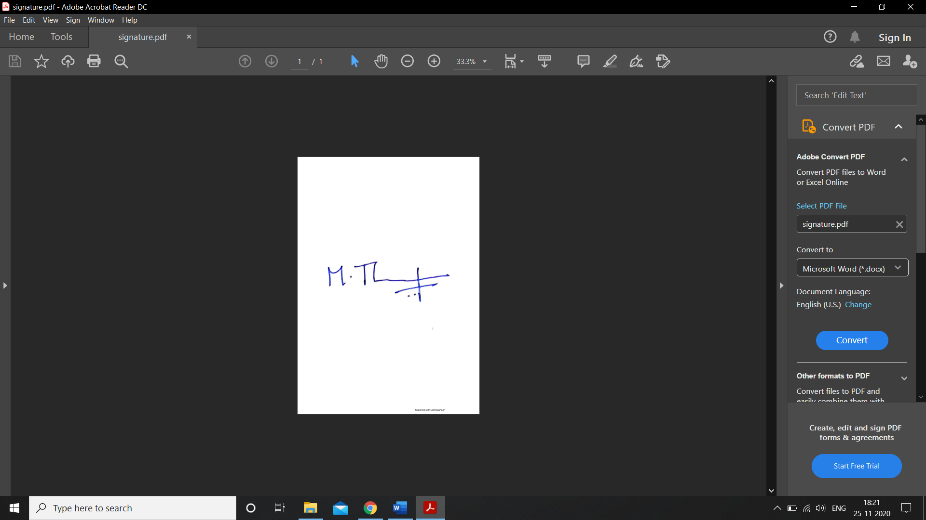
4. | B180473ME | KURAGANTI VEDANTHAM | 5.33 | 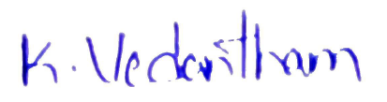

Average CGPA = 7.21

4. Name, email id and Mobile Number of the Group Leader:
Poola Rohith
rohith18p@gmail.com
9441120187

5. Name and Signature of the Project Guide (s):

GUIDE:
Dr. A P Sudheer,
Assistant Professor,
Mechanical Department.

CO-GUIDE:
Dr. K Sekar,
Assistant Professor,
Mechanical Department.

